

**University of Edinburgh**

**School of Geosciences**

Evaluating Forest cover change in red panda (*Ailurus Fulgens*) habitat from 2000 – 2018

*By*

Cameron Cosgrove

In partial fulfilment of the requirement for the

Degree of BSc with Honours in Ecological and Environmental Science

April 2019

# Abstract

Habitat loss has consistently been identified as the largest threat facing the endangered red panda. The species’ low dispersal capabilities, arboreal lifestyle, and narrow distribution also make red pandas particularly susceptible to reproductive isolation cause by habitat fragmentation. For the first time, this dissertation quantifies the extent of habitat loss across the red pandas entire range, and maps the areas of low and high habitat disturbance. My results estimate an area of XXX km2 of forest habitat has been lost since 2000 - 2018. The XXX area and the YYY area show the most pronounced forest loss. No countries show a net increase in forest from 2000 - 2012 in red panda habitat. Protected areas sufficiently/insufficiently protect forest. Habitats at lower elevation show the highest amount of habitat loss, which correlates with higher human population. The forest network in red panda habitat is likely fragmented into 3 isolated populations, with X habitat bottlenecks experiencing moderate to high disturbance. The conservation implications of this work are…

Table of Contents

Abstract 2

Table of Contents 3

Acknowledgements 4

List of abbreviations 5

1. Introduction 6

The red panda 6

Ecology 6

Threats and current conservation efforts 7

1.3 Project Rationale 7

A remote sensing approach 8

1.4 Research questions and hypotheses 8

3.1 What change has occurred to forests in red panda habitat? 8

2. Methods 9

2.1 Defining the study area 9

2.2 Data collection 9

Global Forest Change Dataset 9

Red Panda distrubution 9

2.3 Data processing 9

Forest Change 9

Hot spot identification 9

2.4 Data analysis 9

3. Results 9

3.1 What change has occurred to forests in red panda habitat? 10

3.2 Where has forest been lost in red panda habitat? 10

4. Discussion 10

4.1 How is Red Panda Habitat changing? 10

4.2 Conservation implications 10

4.3 Limitations 10

4.4 Future work 10

5. Conclusion 10

6. References 10

7. Appendices 11

Acknowledgements

List of abbreviations

GEE – The google earth engine

MaxEnt – Maximum entropy distribution model

IUCN

CITIES

1. Introduction

Terrestrial mammal populations are changing rapidly around the world. Mammal Populations are both increasing and decreasing as a result of human activity such as hunting and ecosystem modification. SOME DATA FROM A STUDY WOULD BE NICE HERE. This is of concern for a number of ethical, practical, and aesthetic reasons. Much scientific attention is given to reversing these changes and finding evidence based solutions for mammal conservation. Species specific conservation plans require a plethora of data to make informed decisions, yet data is often unavailable due to the remoteness of field sites, and the absence of funding.

Habitat change and fragmentation represent the primary anthropogenic drivers of ecosystem change. Species with narrowly defined niches and low dispersal capabilities often respond poorly to ecosystem change and show the most significant population declines. The red panda, which has reportedly declined by over 40% over the last 50 years, is one such species. Conservation efforts for red pandas could be helped by understanding how its forest habitat is changing across its entire range. My project uses a new remote sensing dataset detect forest cover change (a proxy for habitat change) in red panda habitat and attempts to draw useful range wide conservation implications.

The red panda

Ecology

Red pandas are exacting in their habitat requirements. Attitudinally bound on the southern slopes of the Himalayas, occupying fairly homogenous forests. Species distribution models work well with this species.

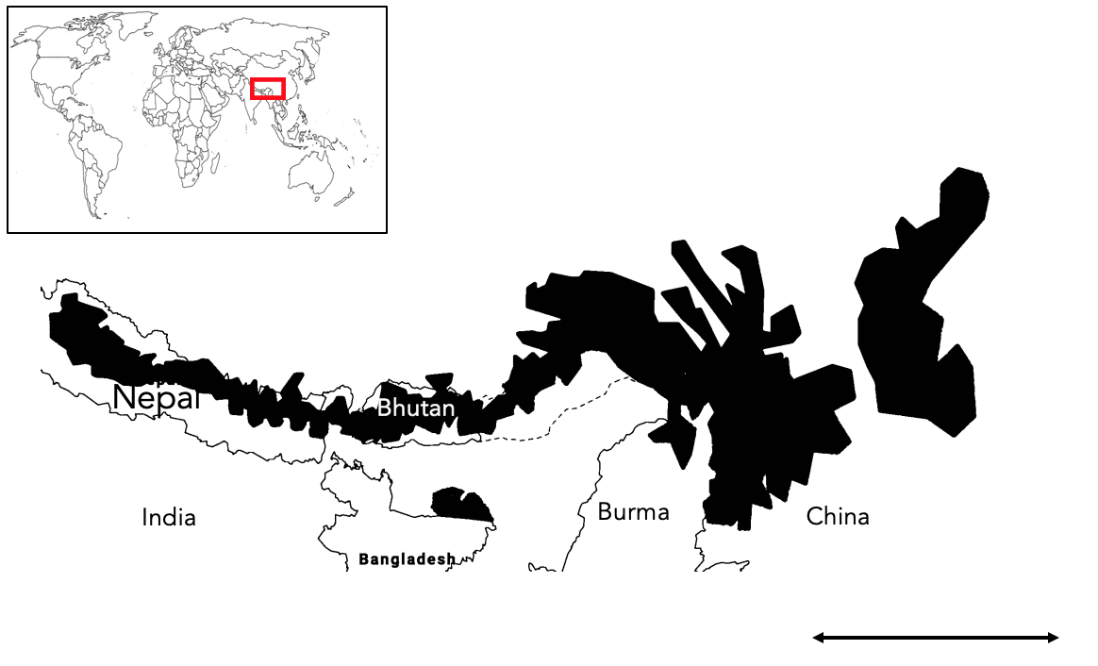Low density and mainly solitary/ Fecundity? Three known isolated populations. Diet

Two genetically distinct populations of red pandas exist. Separated by X river valley. Previously considered a sub species, genetic analysis now suggests they are two distinct species. This taxonomic view is still debated. Slitting the species will have conservation implications and as such I have made a distinction between the two sub species in this dissertation

Threats and current conservation efforts

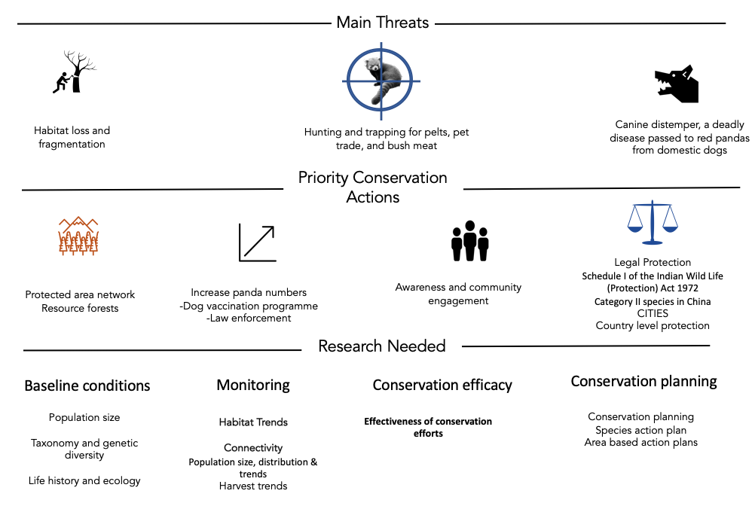Local action. Wide scale measures are not red panda specific. No coordinated range wide management plan exists. I have found it suspiring that there is not more research and conservation interest for the red panda, considering it is cute af. The species primaritly suffers from lack of research due to remote distribution, however much of its habitat is now accessible.

1.3 Project Rationale

Knowledge gap. There is a want to develop a range wide transboundary conservation plan for red pandas. This involves:

* identifying the core and most threatened bits of habitat
* Is habitat being lost, if so where
* Is the rate of loss increasing?
* Is the habitat connected? Are there at risk bottle necks
* How are pandas doing in different countries
* Is the protected area network sufficient and how should we protect habitat (corridors like tigers?)

A MaxEnt distribution model for Red Pandas was created in 2018 to help identify where important habitat is.

We currently don’t know the big picture of how forest cover is changing. This could lead us to protect the wrong areas or invest resources in inefficient ways. Many of these questions can be answered by pre-existing remote sensing datasets. I think knowing WHAT change is happening to red panda forests and WHERE change is happing would be valuable to conservation decision making process for red pandas. We already know there is insufficient protected area coverage for red pandas, and there are calls to establish new areas to protect pandas. This assumes current pa’s are working for pandas. I am also interested in seeing if this appears to be the case.

A remote sensing approach

Advancement in remote sensing technologies now allow for the rapid collection of relevant ecological measurement across a range of environments. Large datasets describing changes in land cover, vegetation structure and moisture levels are all now publically accessible. However, large datasets require large processing power to create and analyse. The creation of cloud based spatial analysis such as the Google Earth Engine in 2013, provide a free platform to conduct analysis on big spatial data. There are a range of conservation opportunities for this data. In particular, the quantification of land use change. Hansen is appropriate for a first assessment of forest change. Good resolution and accuracy for the size or area being looked at too.

In this dissertation I use s publically available forest cover change dataset to

1.4 Research questions and hypotheses

What change has occurred to forests in red panda habitat?

Deforestation is reportedly occurring across the range of the red panda and is stated as one of the most prominent threats to red pandas. Due to the emphasis put on this threat in the literature I expect a sizable about of forest to have been lost across this entire range. The value of 10% has been chosen arbitrarily to represent a sizable amount of loss. I also expect the rate of forest loss to be increasing as the human population in increasing in red panda habitat. I expect the rate of loss to be increasing linearly as this broadly corresponds with the rate of human expansion in the region.

H1: The area of red panda habitat has decreased by 10% from 2000 to 2018 across the entire range.

H0:

Ha:

H2: The rate of forest loss has increased in red panda habitat from 2000 to 2018 across the entire range.

H0:

Ha:

Where has forest been lost in red panda habitat?

H1: Different countries have lost different proportions of forest cover in red panda habitat.

H2: Lower elevations will be correlated with higher proportions of forest loss

H3: Core areas of habitat will have seen the most forest loss

H4 Higher IUCN ratings have lost the least forest compared to lower ratings and unprotected areas.

2. Methods

2.1 Defining the study area

2.2 Data collection

Global Forest Change Dataset

Red Panda distrubution

2.3 Data processing

Forest Change

Hot spot identification

2.4 Data analysis

Statistical treatment

3. Results

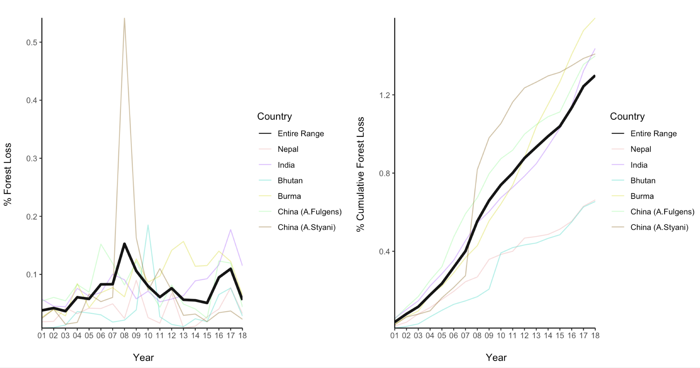3.1 What change has occurred to forests in red panda habitat?

Look into un balanced samples

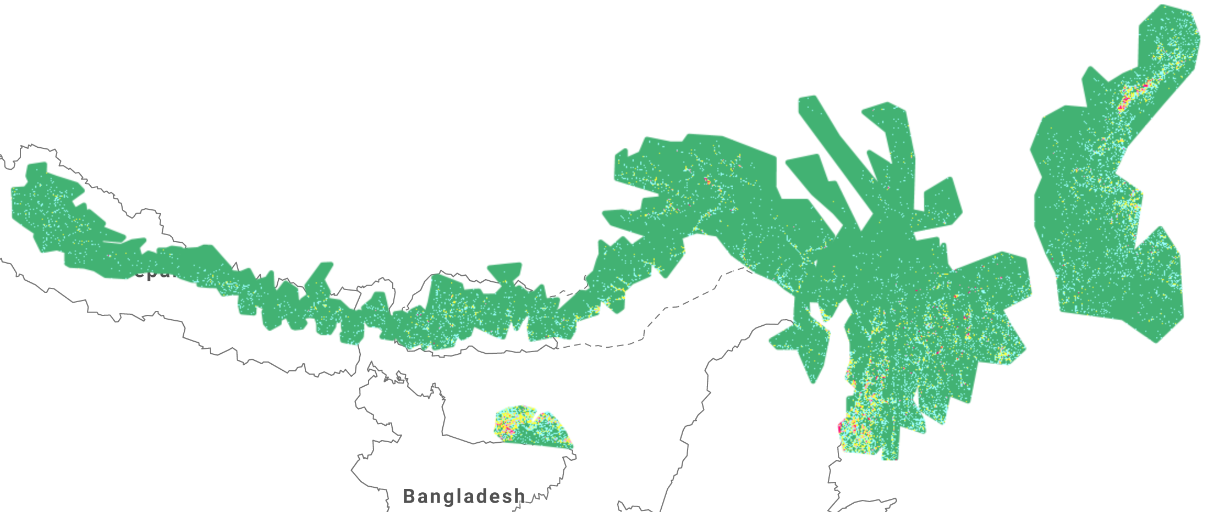3.2 Where has forest been lost in red panda habitat?

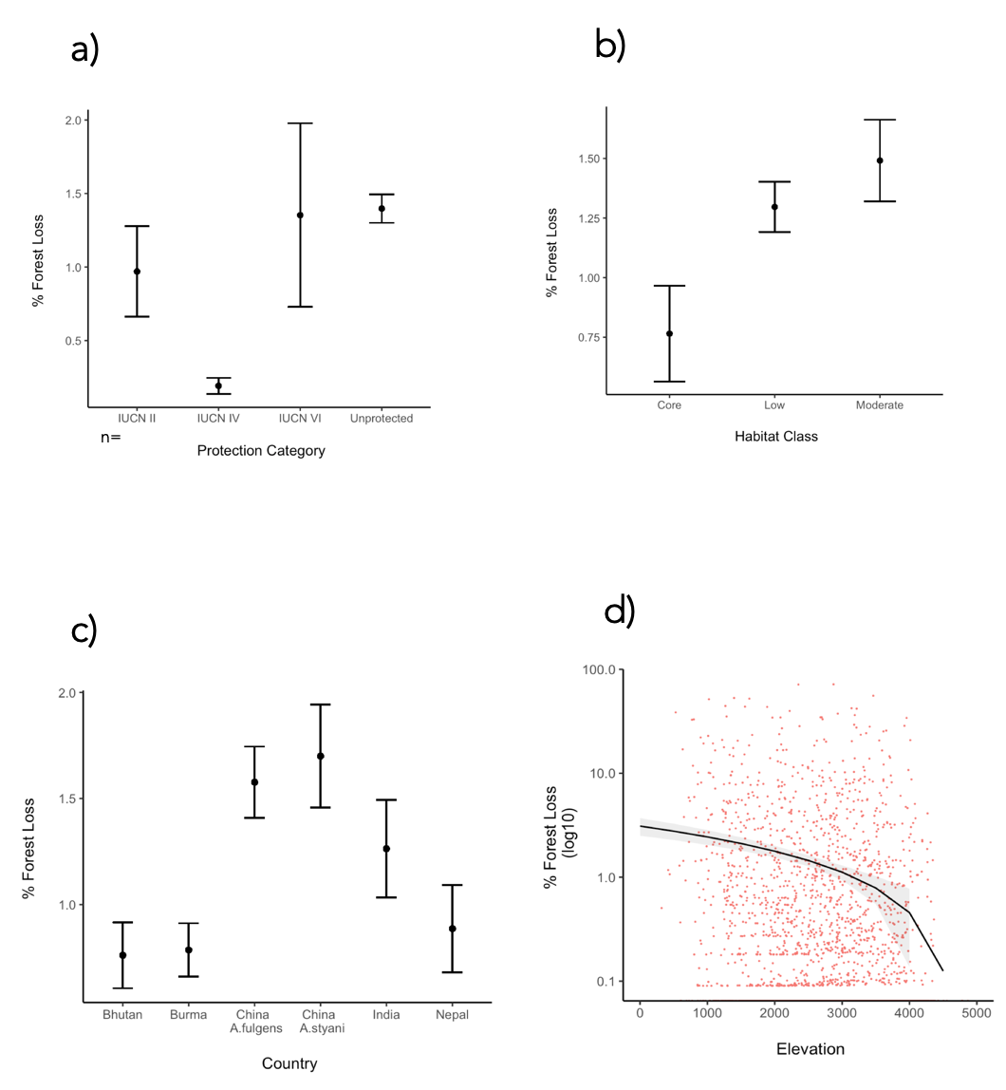

Figure 4

4. Discussion (Demonstrate Understanding!)

Key findings

2-4 points

Highlight what wasn’t known before

4.1 How is Red Panda Habitat changing?

4.2 Conservation implications

4.3 Limitations

What needs to be considered when interpreting my results?

PA analysis should look at where loss is occurring. Not just absolute values as these are low.

Map may over estimate habitat as occurrence records are few and far between. Makes the forest loss analysis less specific to rps and may miss more relevant dynamics

IUCN classes run different in different countries

4.4 Future work

What else should happen in order to design an effective range wide strategy for red pandas? Need to confirm species occurrence. Camera trapping programme

Quantify fragmentation impacts

Panda density estimates

This will work towards identifying connectivity across the range

Sympatric conservation too with Tiger conservation, Mishmi Tackin and other species of conservation concern. Large overlapping habitat.

Active remote sensing could be used key panda areas to monitor change to the structure of the vegetation and

Forest loss to gain has only been calculated for the entire range. I would explore how gain changed too.

5. Conclusion

6. References

7. Appendices